Read the assigned article, "Are You Paying Too Much for That Acquisition?" by Eccles, Lanes, and Wilson, from Harvard Business Review (1999).
In the textbook, complete the following problems.
- Problem 7.11 (Show calculations for a, b, and c.)
- Problem 7.12 (Show calculations for a and b.)
Using information from "Are You Paying Too Much for That Acquisition?" address the following with a minimum of 500 words.
- List and describe the components used to calculate synergy value.
- Critically evaluate which component is most underestimated. Explain your answer.
- Using the attached spreadsheet "Excel-Based M&A Valuation and Structuring Model," open the worksheet labeled BP APP B2 and study the Net Sales Growth Rate for 2002-2005. Next, open the worksheet labeled BP APP B1 and study the 2006-2010 Net Sales Growth Forecasts. Lastly, reference "Are You Paying Too Much for That Acquisition?" to identify the basis or rationale for justifying the 2006-2010 forecasts.
APA format is required for essays only.
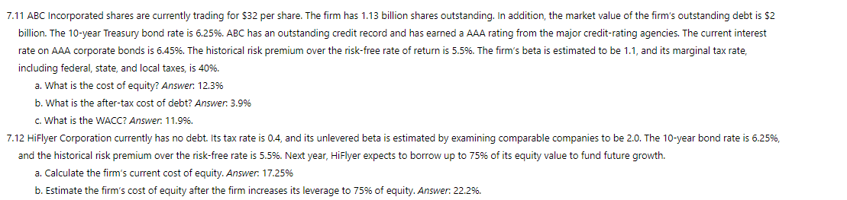
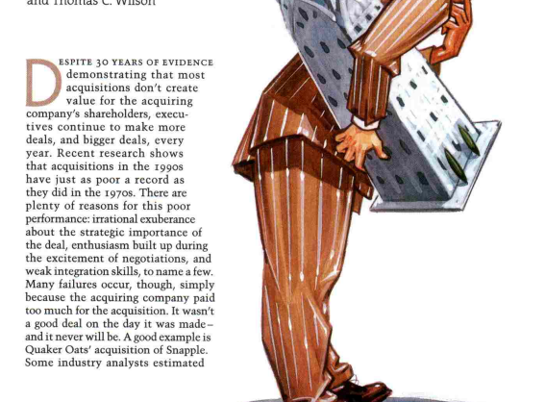

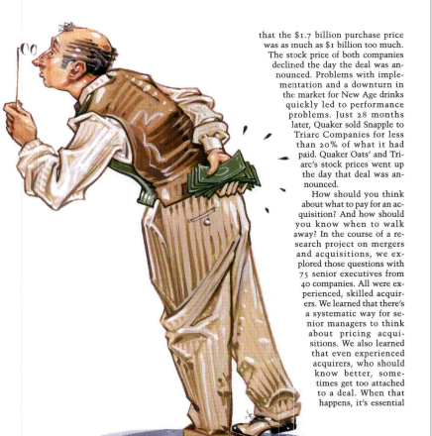
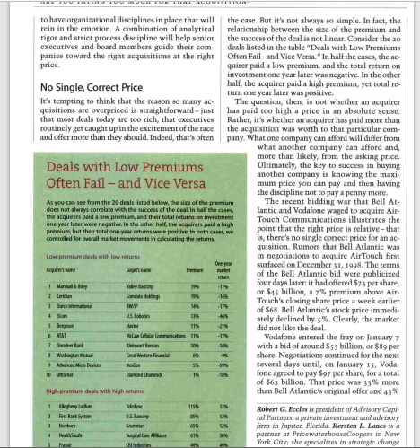
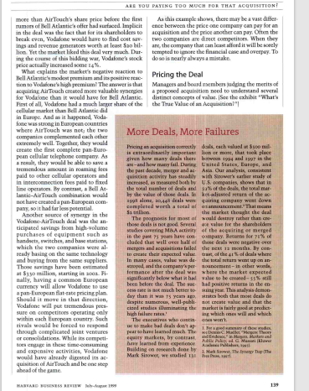
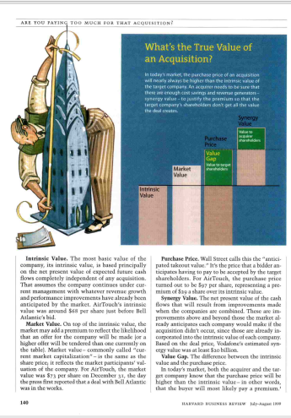
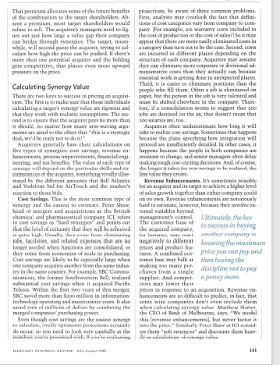
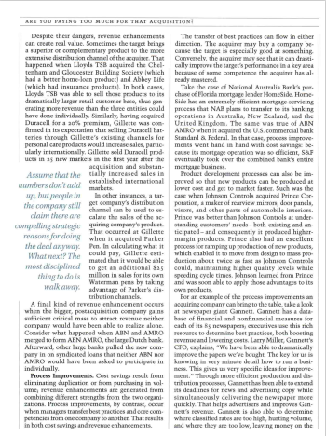
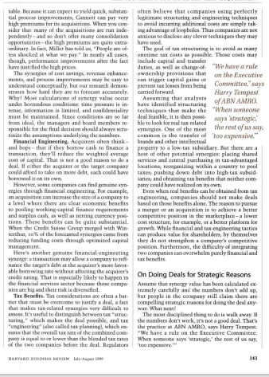
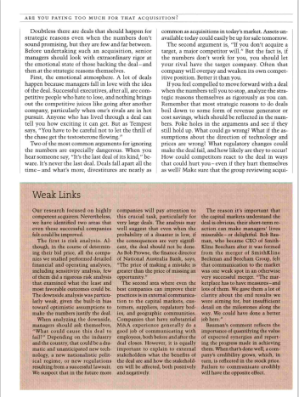
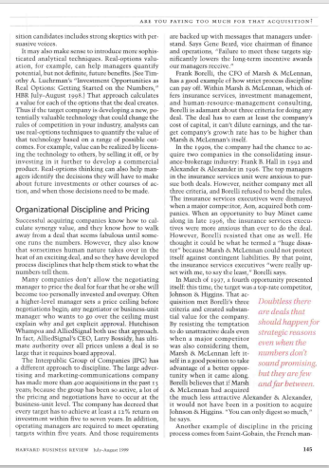
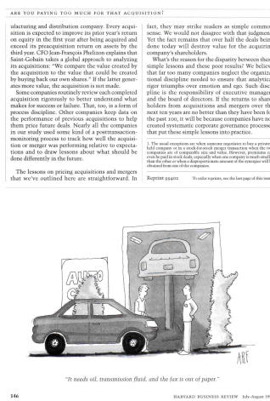
References
Eccles, R. G., Lanes, K. L., & Wilson, T. C. (1999). Are You Paying Too Much for That Acquisition? Harvard Business Review, 77(4), 136–146.

